Docker architecture:
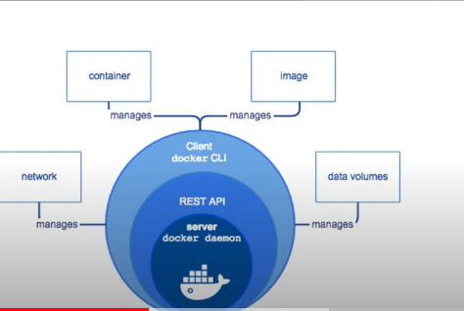
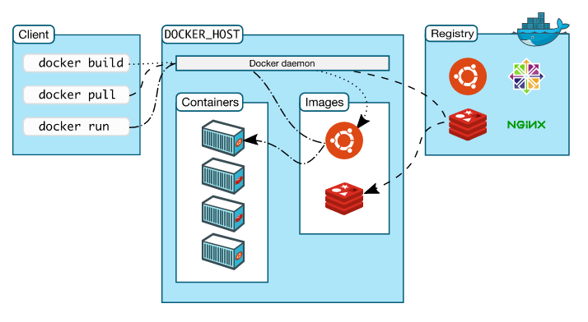
Docker client:
Docekr client is the primary way that many users to interact with the docker.when you use commands such as docker run ,client sends these commands to docker deamon.the docker command uses the docekr api.
Docker deamon:
docker deamon listens docker api requests ,and manages docker objects such as images,containers,networks,volumes.
Docker Registery: a registery stores docker images.

Docker components:
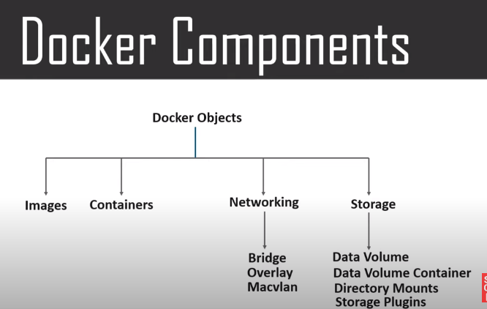

Image :
images describe the container capabilities and needs.
images used to store and shift applications.
Images used to build container.
Containerd images shared across the public registery.
Containers:
Containers are encapsulated environments to in which you run the applications. containers are defined by the image.
Containers only have the resources that are defined in the image.
Containers much smaller than the vm’s ,they spin up in a matter of secs.
Networking:
Docker networking is a passage through which all the isolated containers communicate.
Network drivers:
- Bridge.==>it is default network driver for a container.useful when multiple containers communicating with the same dockerhost.
- Overlay: useful when docekr containers runnig on multiple docker host.

Storage:
you can store the data within the writable layer of the container.for that it requires storage driver.
Volume types:
Data volume
Data volume container.
Directory mounts
Storage plugins.

